Aplicación 2.4. Curva de Engel para el gasto en alimentos (II)

J. Ramajo

2020

**1. Lectura y análisis exploratorio de datos**

Lectura de librerías

library(readr)  
library(car)

## Loading required package: carData

library(MASS)  
library(effects)

## Registered S3 methods overwritten by 'lme4':  
## method from  
## cooks.distance.influence.merMod car   
## influence.merMod car   
## dfbeta.influence.merMod car   
## dfbetas.influence.merMod car

## lattice theme set by effectsTheme()  
## See ?effectsTheme for details.

library(tidyverse)

## ── Attaching packages ──────────────────────────────────────────────────────────────────────────── tidyverse 1.3.0 ──

## ✓ ggplot2 3.3.1 ✓ dplyr 1.0.0  
## ✓ tibble 3.0.1 ✓ stringr 1.4.0  
## ✓ tidyr 1.1.0 ✓ forcats 0.5.0  
## ✓ purrr 0.3.4

## ── Conflicts ─────────────────────────────────────────────────────────────────────────────── tidyverse_conflicts() ──  
## x dplyr::filter() masks stats::filter()  
## x dplyr::lag() masks stats::lag()  
## x dplyr::recode() masks car::recode()  
## x dplyr::select() masks MASS::select()  
## x purrr::some() masks car::some()

Lectura de datos

load("~/Documents/R/R_ECOMET_Ramajo/GASTO_ALIM.RData")

Gráficas

attach(GastoAlim)  
# Análisis exploratorio  
summary(GastoAlim)

## wAlim GTotal EdadPRHog TamHog   
## Min. :0.0000 Min. : 14601 Min. :16.00 Min. : 1.000   
## 1st Qu.:0.2583 1st Qu.: 449820 1st Qu.:38.00 1st Qu.: 2.000   
## Median :0.3642 Median : 731114 Median :50.00 Median : 4.000   
## Mean :0.3783 Mean : 865550 Mean :50.54 Mean : 3.695   
## 3rd Qu.:0.4847 3rd Qu.: 1112533 3rd Qu.:62.00 3rd Qu.: 5.000   
## Max. :0.9966 Max. :11397547 Max. :99.00 Max. :37.000   
## TamMun SexoPRHog   
## Min. :1.000 Length:23972   
## 1st Qu.:2.000 Class :character   
## Median :4.000 Mode :character   
## Mean :3.241   
## 3rd Qu.:4.000   
## Max. :5.000

#  
hist(log(GTotal), freq = FALSE)  
lines(density(log(GTotal)), col = 4)

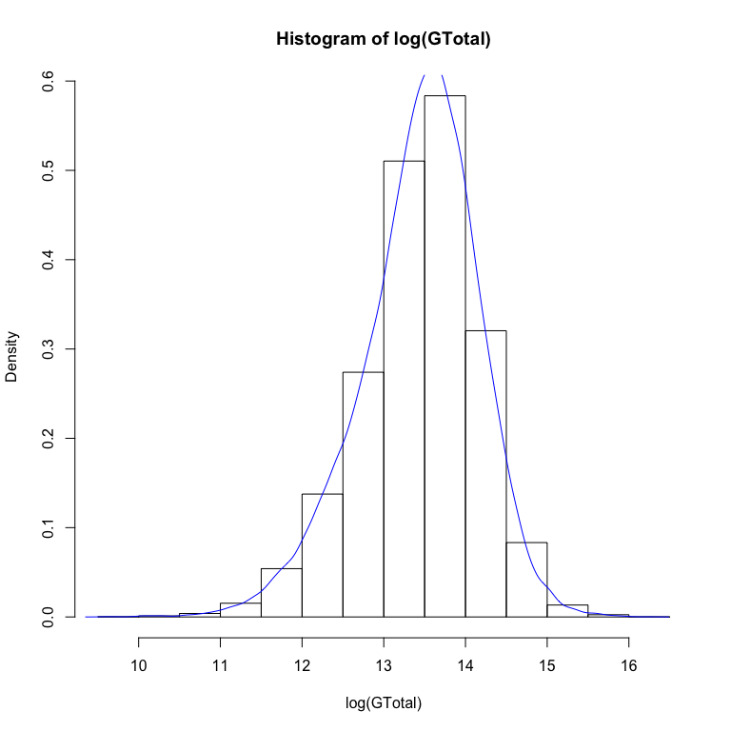

# Diagramas de puntos  
plot(wAlim ~ as.factor(SexoPRHog))

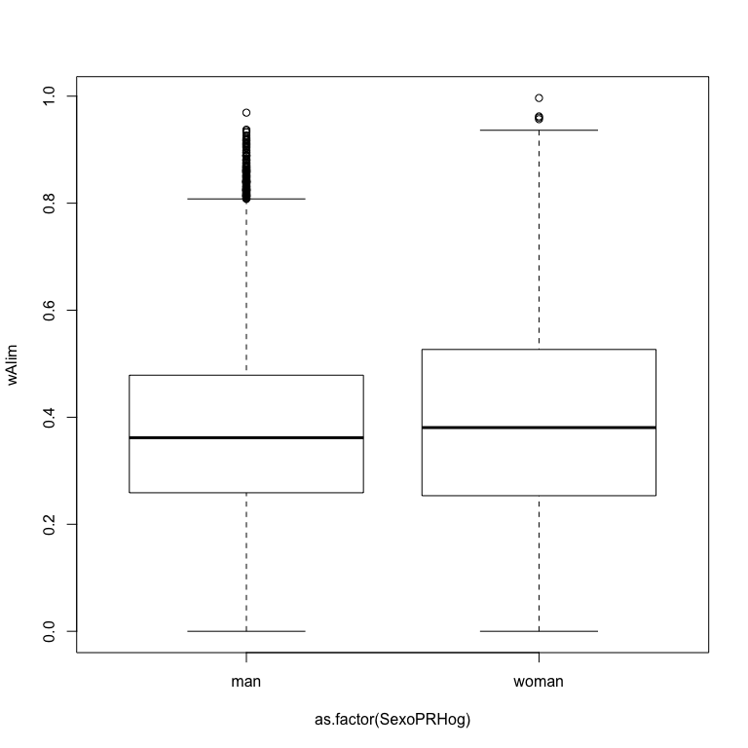

plot(wAlim ~ TamHog)

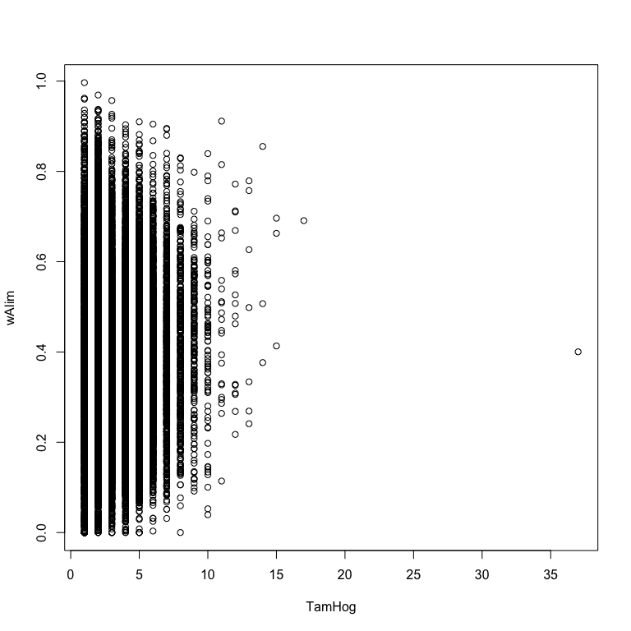

plot(wAlim ~ TamMun)

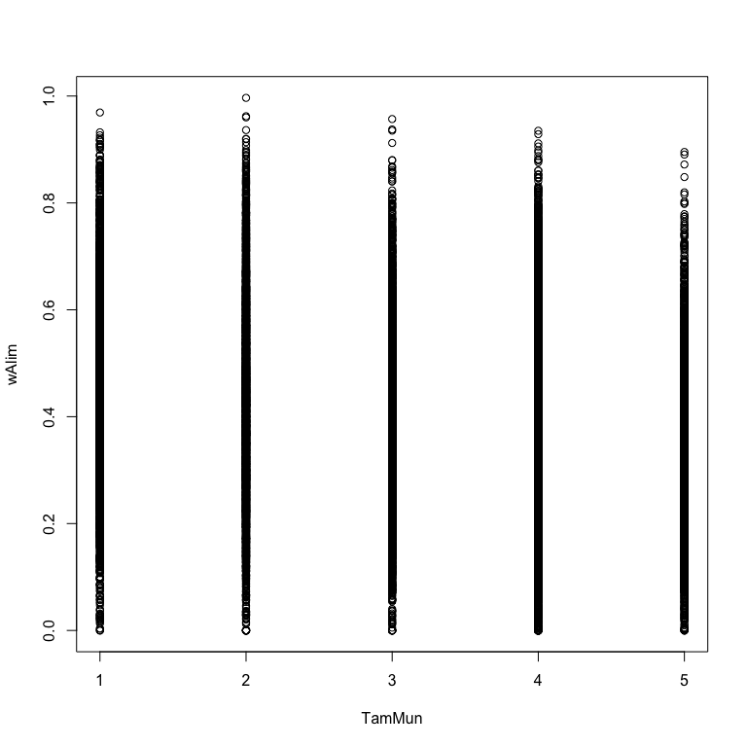

plot(wAlim ~ EdadPRHog)

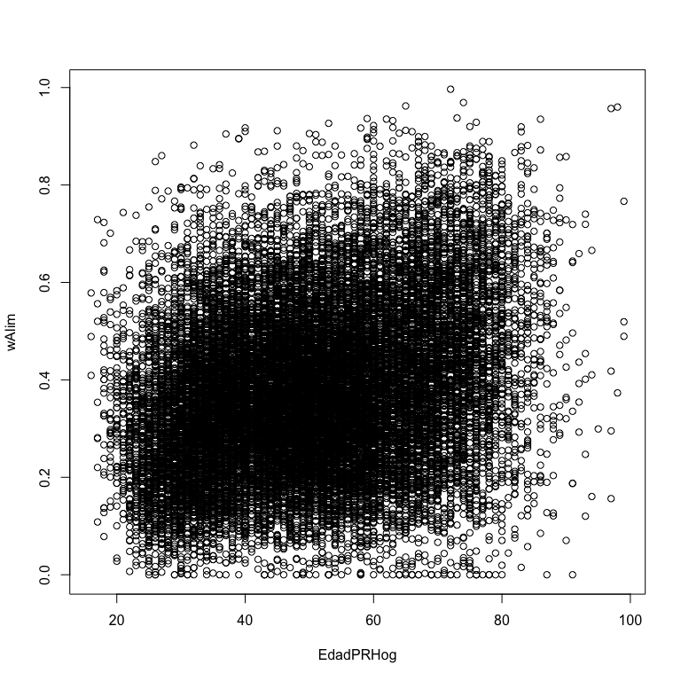

plot(wAlim ~log(GTotal))

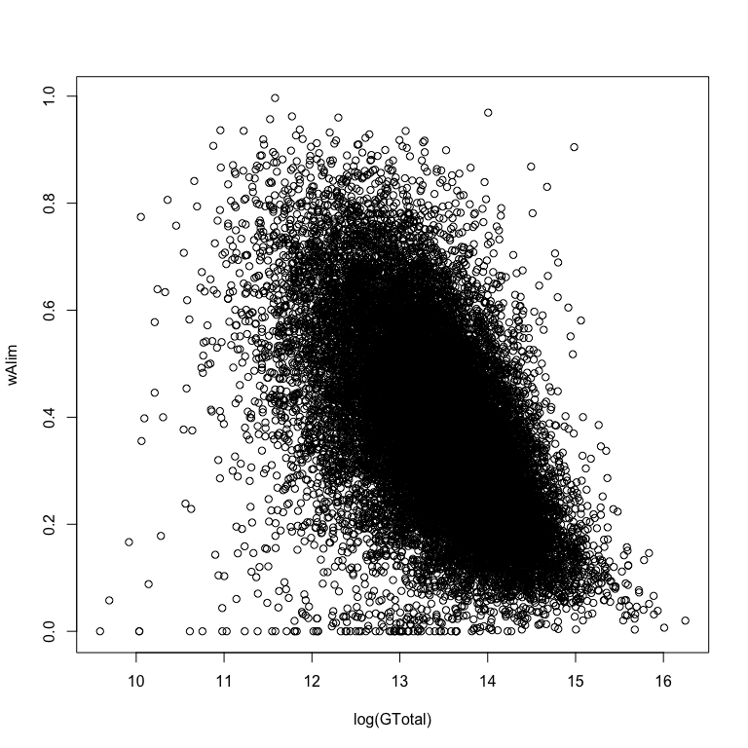

**2. Análisis econométrico**

Engel_lm <- lm(wAlim ~ log(GTotal) + EdadPRHog + TamHog + TamMun + as.factor(SexoPRHog))  
summary(Engel_lm)

##   
## Call:  
## lm(formula = wAlim ~ log(GTotal) + EdadPRHog + TamHog + TamMun +   
## as.factor(SexoPRHog))  
##   
## Residuals:  
## Min 1Q Median 3Q Max   
## -0.85097 -0.08038 -0.00808 0.07648 0.67336   
##   
## Coefficients:  
## Estimate Std. Error t value Pr(>|t|)   
## (Intercept) 2.203e+00 1.912e-02 115.24 <2e-16 ***  
## log(GTotal) -1.448e-01 1.416e-03 -102.26 <2e-16 ***  
## EdadPRHog 1.350e-03 6.196e-05 21.79 <2e-16 ***  
## TamHog 2.695e-02 5.592e-04 48.20 <2e-16 ***  
## TamMun -1.302e-02 7.201e-04 -18.09 <2e-16 ***  
## as.factor(SexoPRHog)woman -3.153e-02 2.623e-03 -12.02 <2e-16 ***  
## ---  
## Signif. codes: 0 '***' 0.001 '**' 0.01 '*' 0.05 '.' 0.1 ' ' 1  
##   
## Residual standard error: 0.1292 on 23965 degrees of freedom  
## (1 observation deleted due to missingness)  
## Multiple R-squared: 0.3914, Adjusted R-squared: 0.3913   
## F-statistic: 3082 on 5 and 23965 DF, p-value: < 2.2e-16

par(mfrow = c(2, 2))  
plot(Engel_lm)

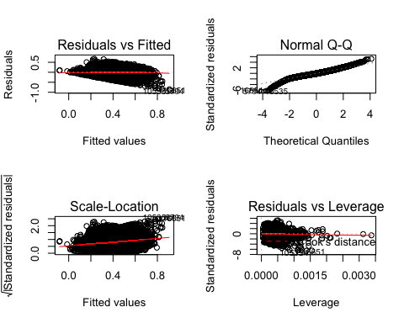

par(mfrow = c(1, 1))